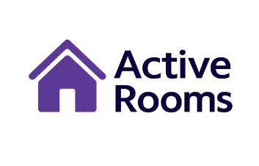
Our web-based system provides an advanced, user-friendly, and intuitive solution for real-time monitoring and supervision of spaces. The user-friendly interface enables full control over the space, efficient occupancy management, and optimized resource utilization. The system provides managers with an up-to-date and accurate overview, allows workflow optimization, and enhances productivity in resource management.

The goal of the project is to develop a versatile web-based system for real-time space occupancy monitoring, designed to be adaptable for various environments such as shopping malls, commercial centers, parking lots, public areas, and government offices. The system will enable effective supervision and control, optimize resource management, and become a generic, multi-purpose tool for different users.

- Login Page

- Permissions Management & Control

- Interactive Map

- User-Friendly Interface

- Data Addition
- Data Modification
- Data Editing
- Visual Access on Map
- Navigation Between Areas

Students Shalev Ozeri-212229298
Dana Mund-319126074
PM
Eliel Yeshayahu

Our methodology involves developing a responsive web application using React for both desktop and mobile devices, with data reception and storage handled via a MySQL relational database that stores system parameters, user details, and other settings.



Problem
Lack of real-time supervision and visibility over classroom occupancy and utilization.
Solution
An optimized web and mobile platform designed to streamline and enhance real-time classroom occupancy monitoring and management.
Occupancy Monitoring ● Class Scheduling & Availability ● Sensor & Rooms Management ● Analytics & Dashboards
Active Room Hit Project

